UI :

SAMPLE INPUTS AND OUTPUTS:

USER SIDE:

HOME PAGE : HOME.PHP

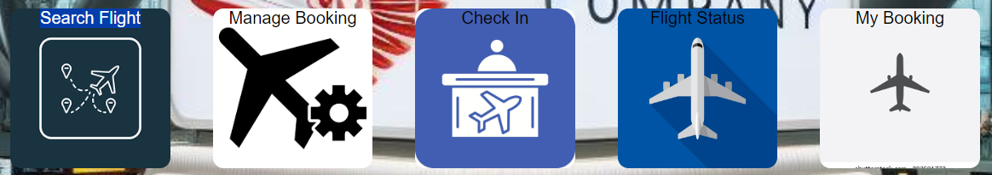

BEFORE LOGIN :

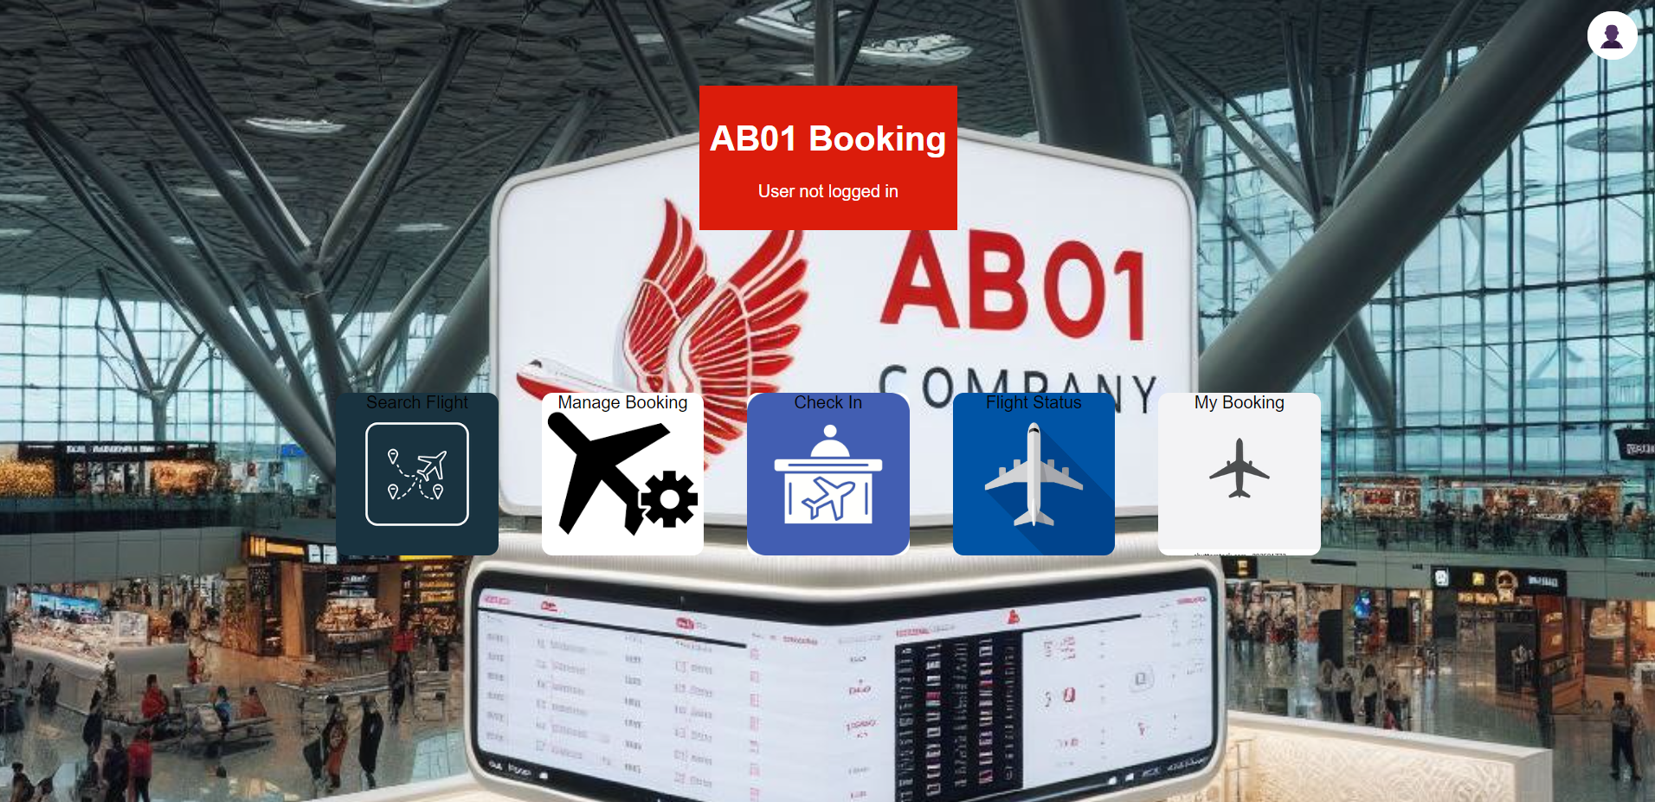

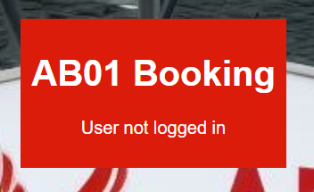

AFTER LOGIN:

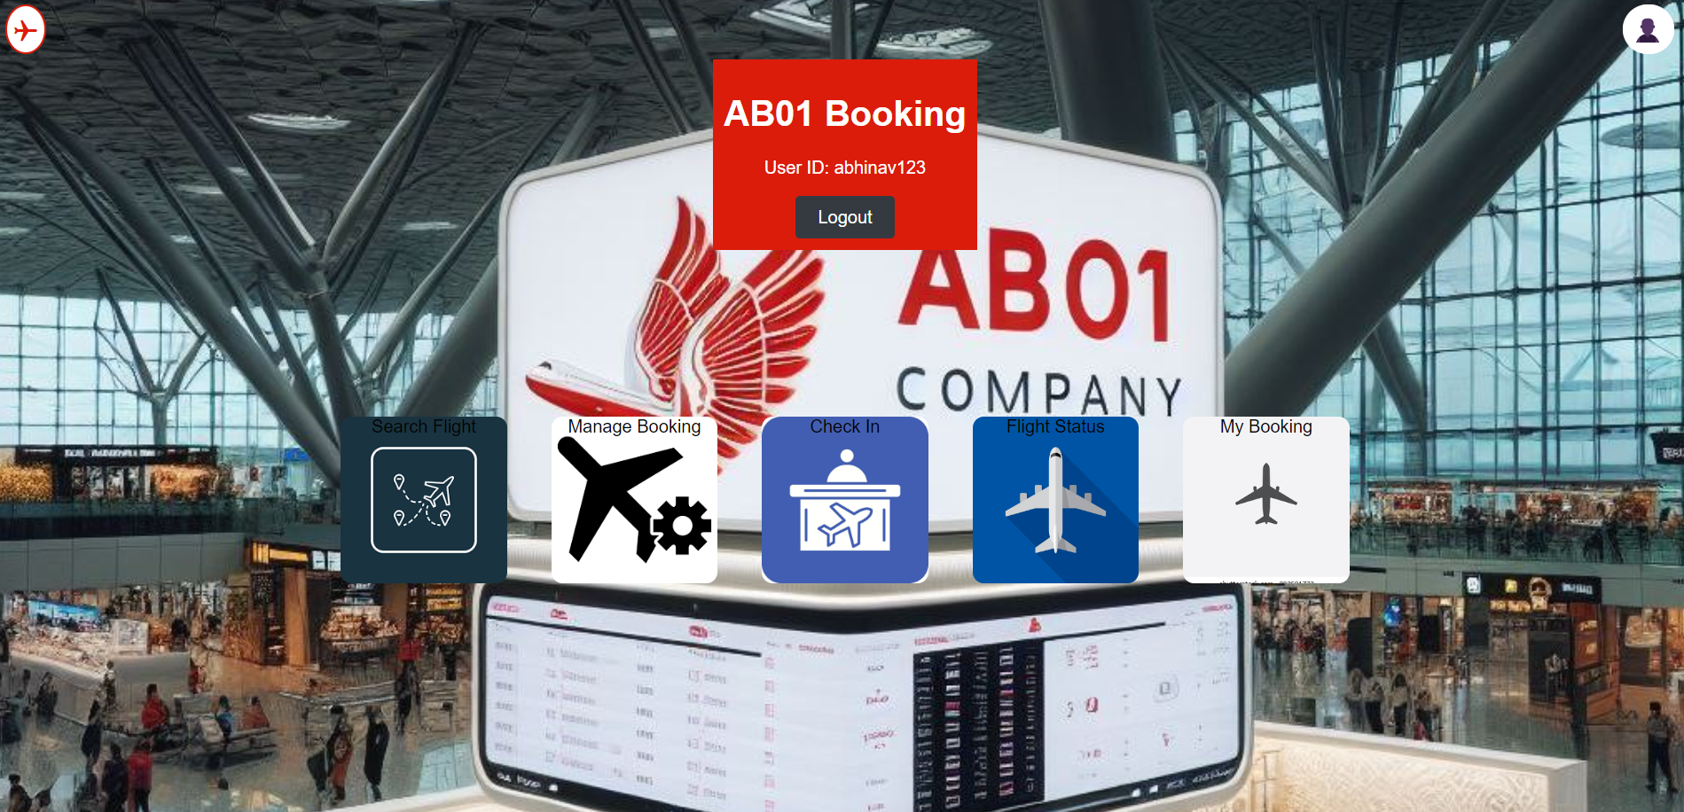

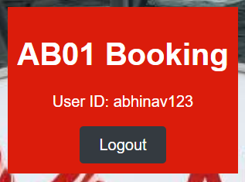

SIGNUP PAGE: SIGNUP.PHP

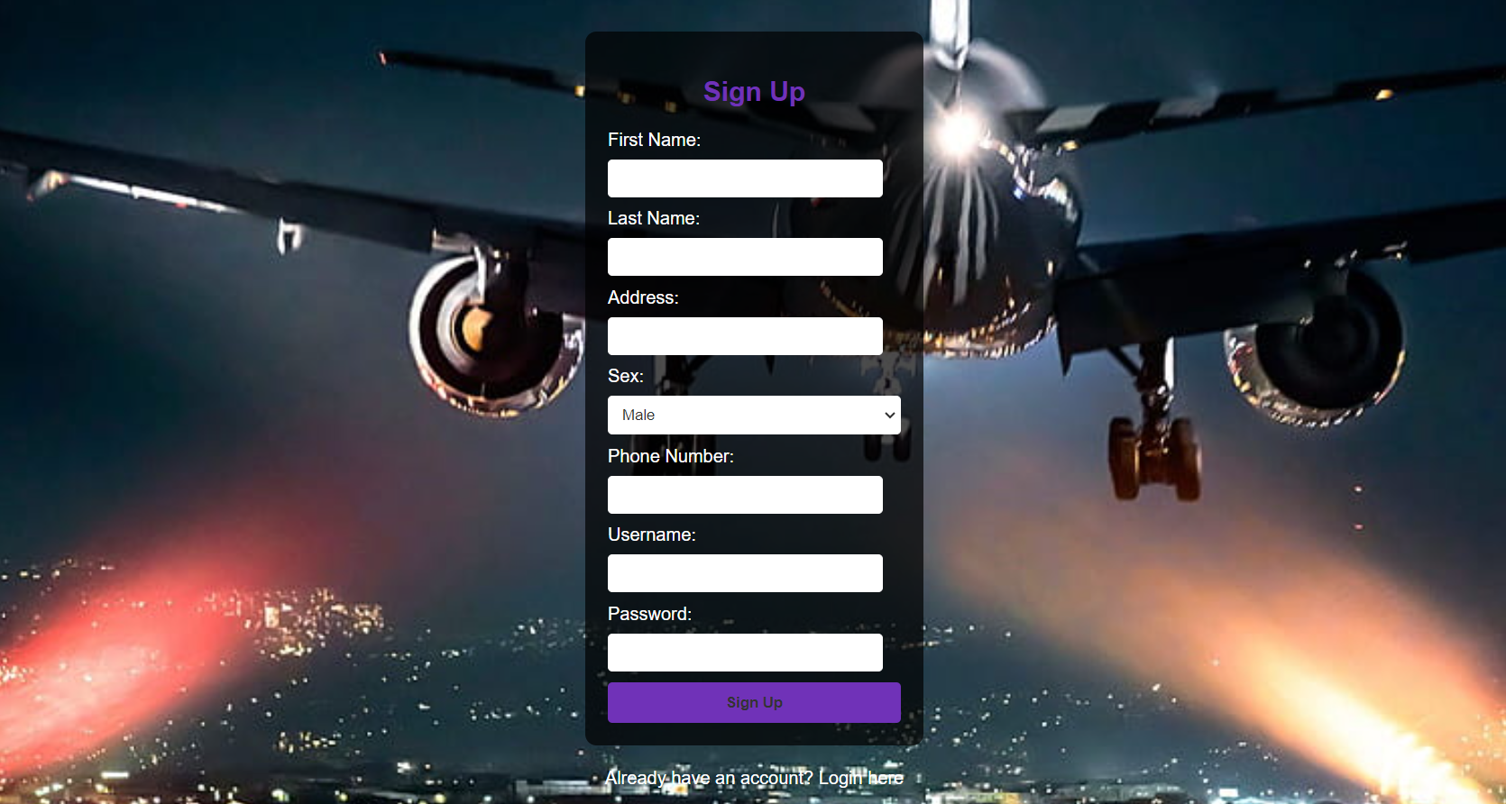

LOGIN PAGE: LOGIN.PHP

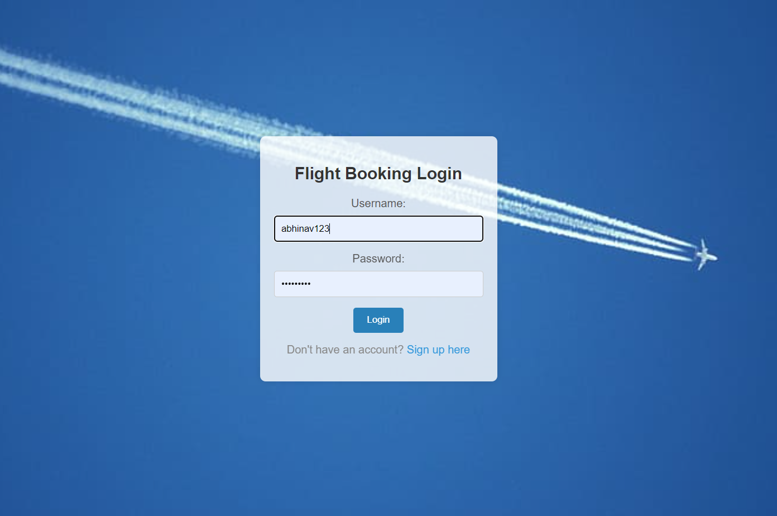

USER DETAILS PAGE : USERDETAILS.PHP

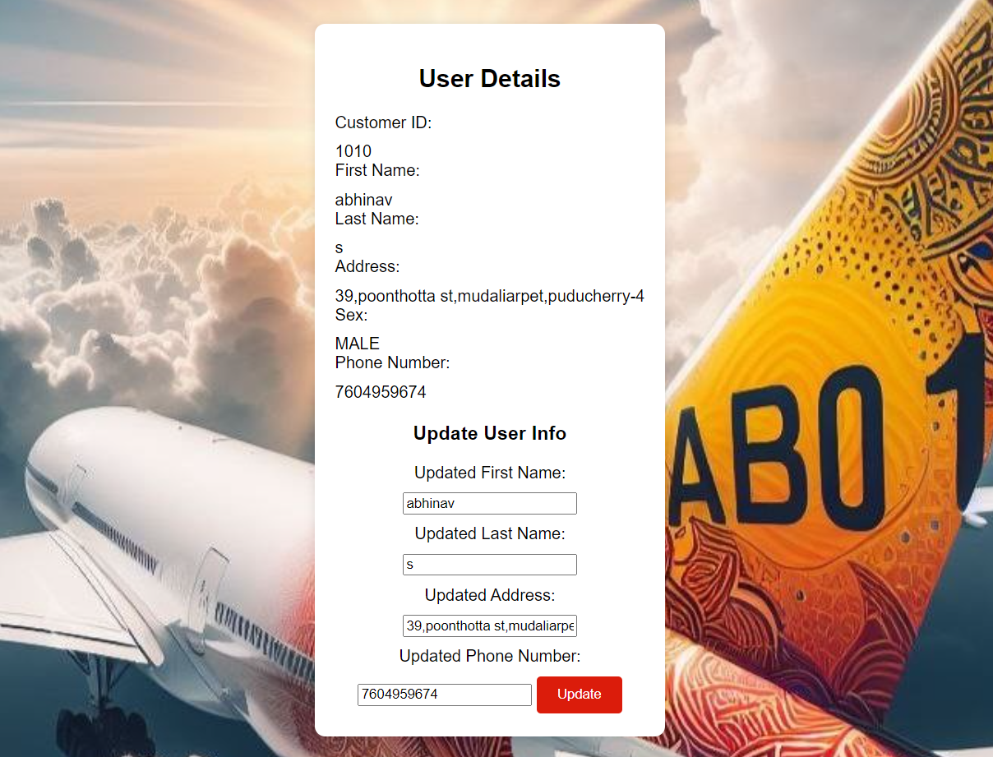

MY BOOKINGS PAGE : MYBOOKINGS.PHP

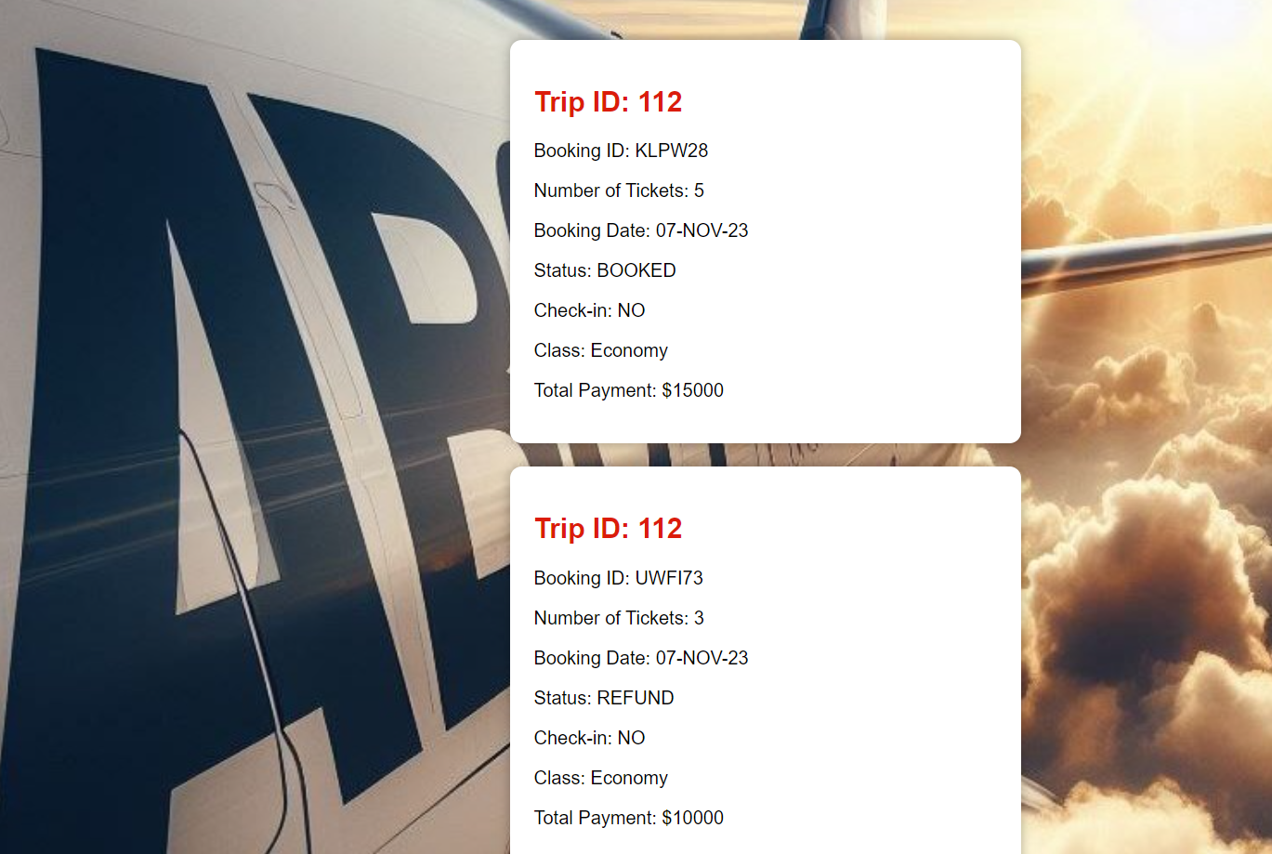

CHECK FLIGHT STATUS PAGE : FLIGHTSTATUS.PHP

INPUT:

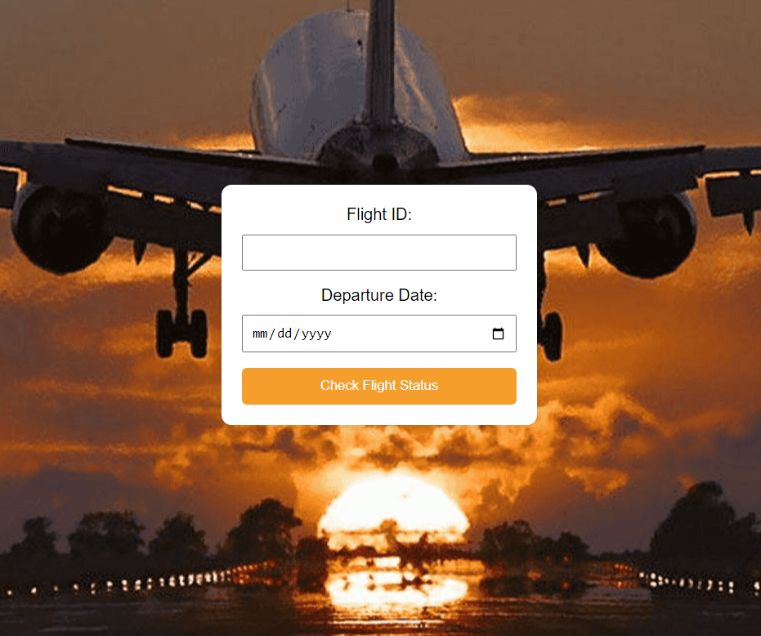

OUTPUT:

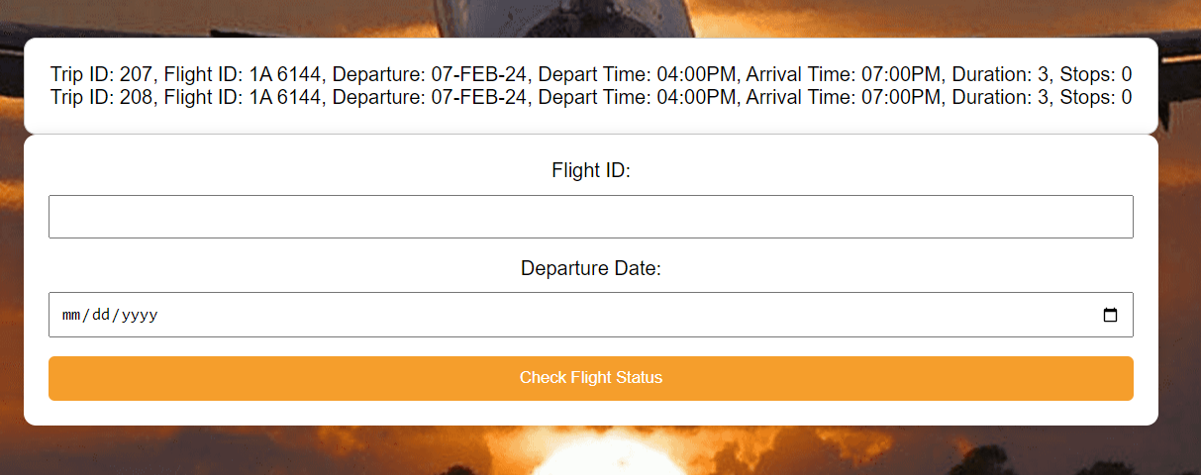

CHECK IN PAGE : CHECKIN.PHP

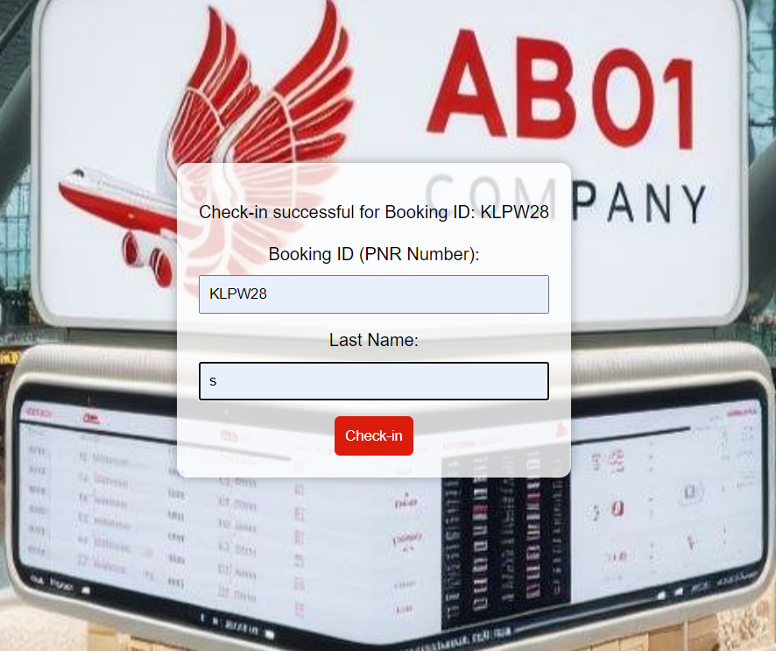

MANAGE BOOKING PAGE : MANAGEBOOKING.PHP

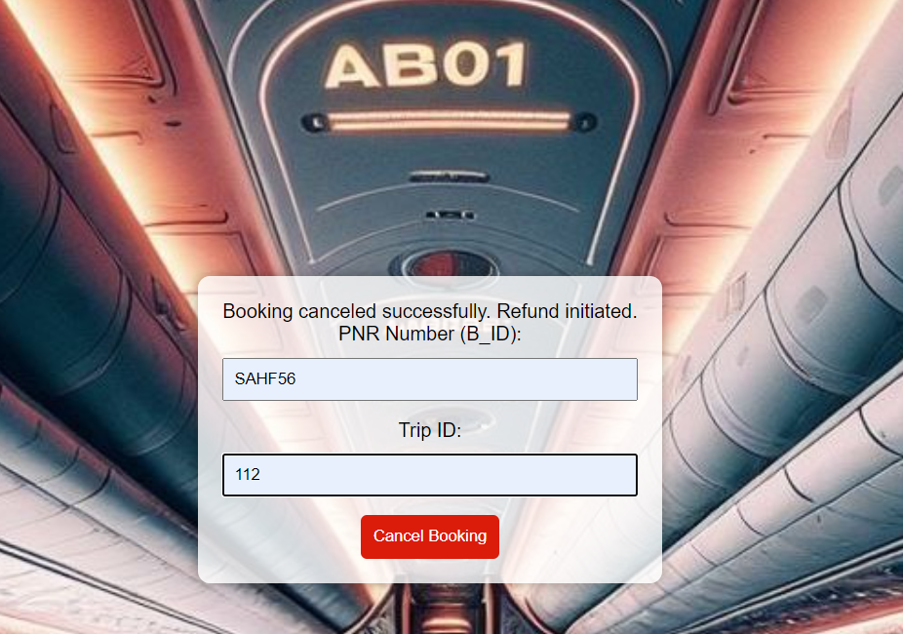

SEARCH FLIGHTS PAGE : SEARCHFLIGHT.PHP ---> BOOKING.PHP

INPUT:

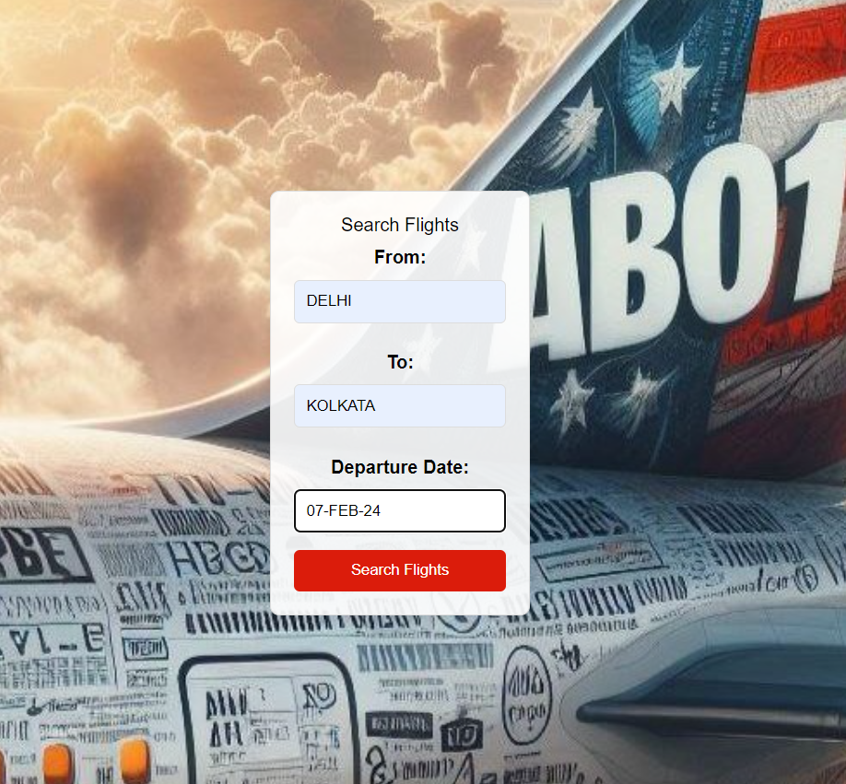

OUTPUT:

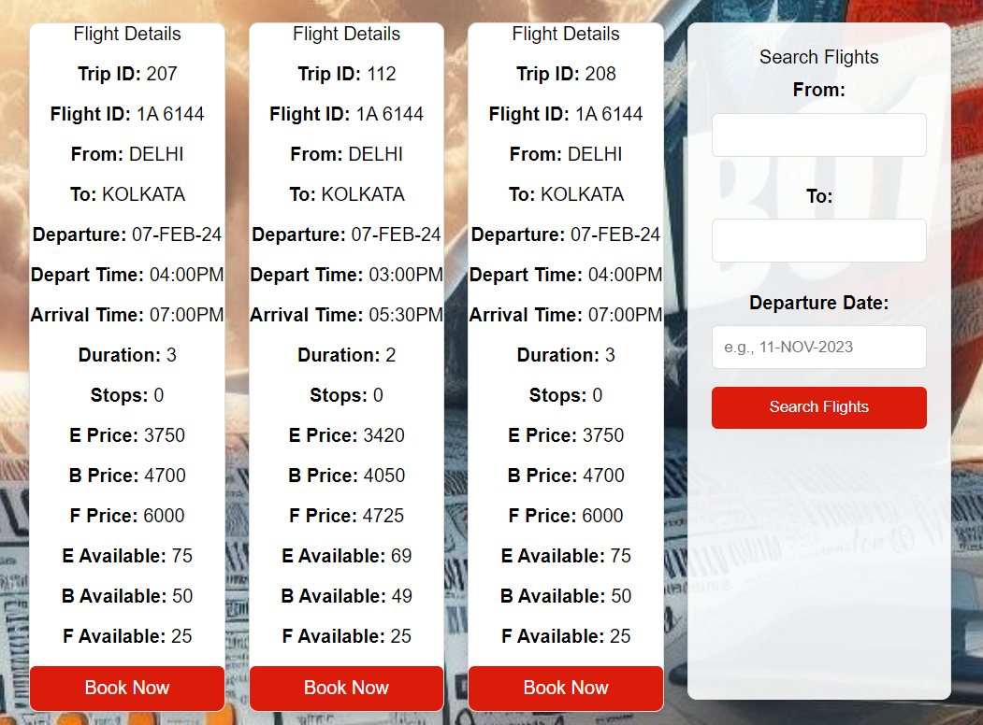

BOOKING PAGE : BOOKING.PHP

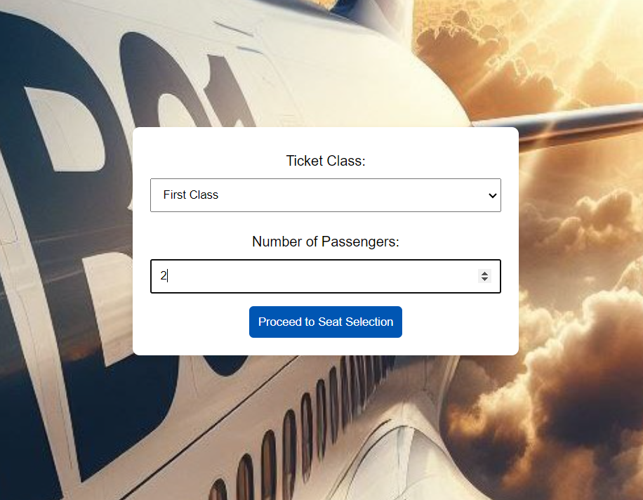

SEAT SELECTION PAGE: SEATGEN.PHP

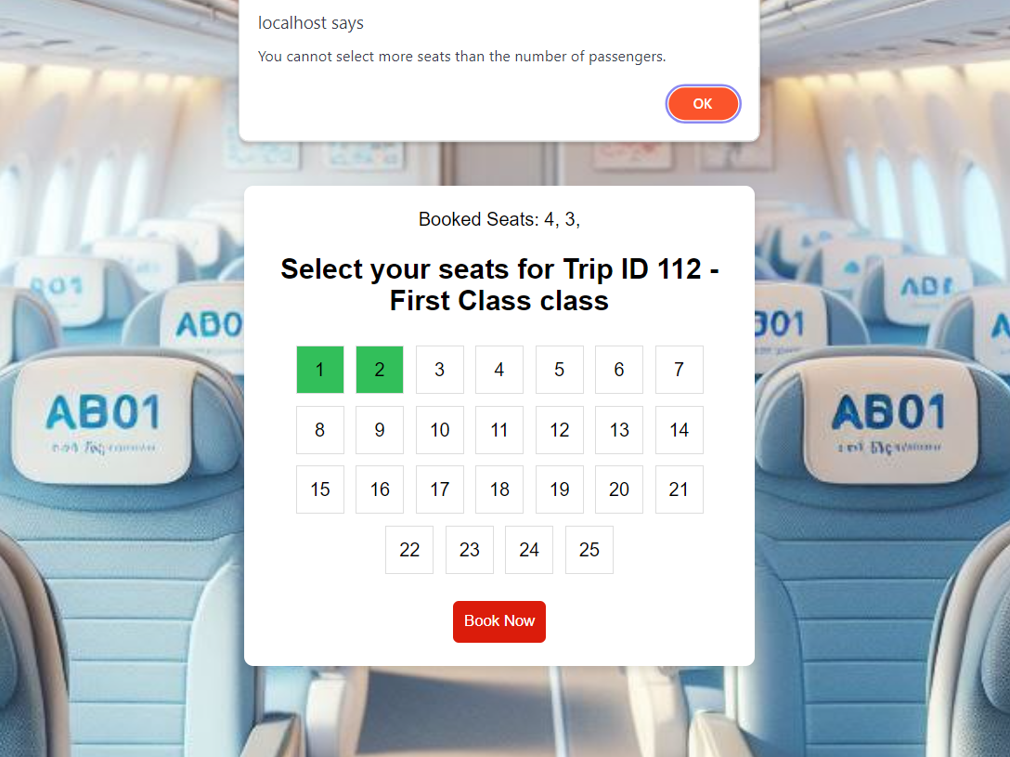

FINALBOOKING.PHP

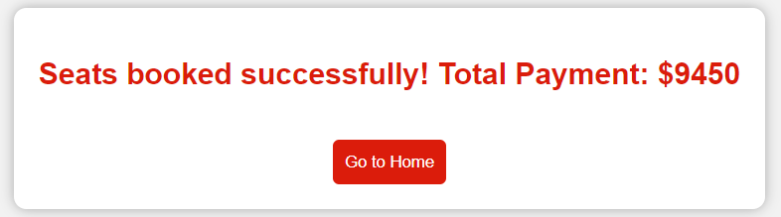

ADMIN SIDE:

HOME PAGE : ADMIN_HOME.PHP

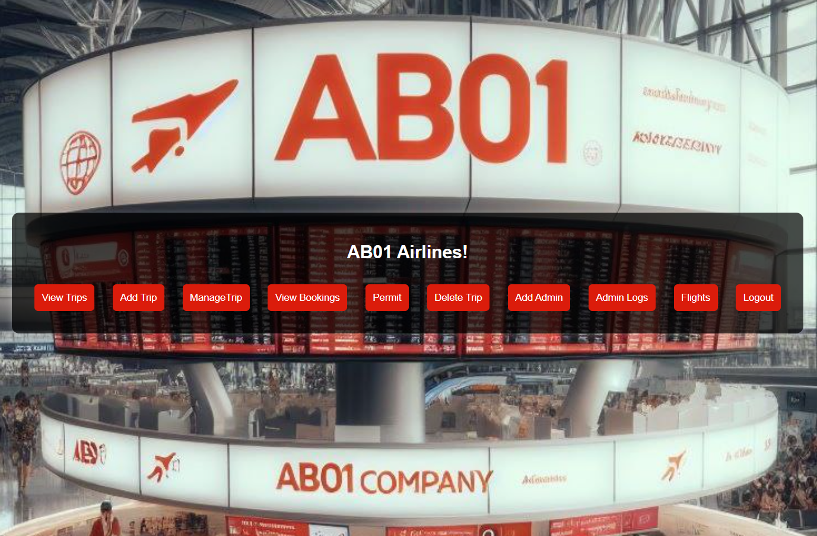

LOGIN PAGE : ADMINLOGIN.PHP

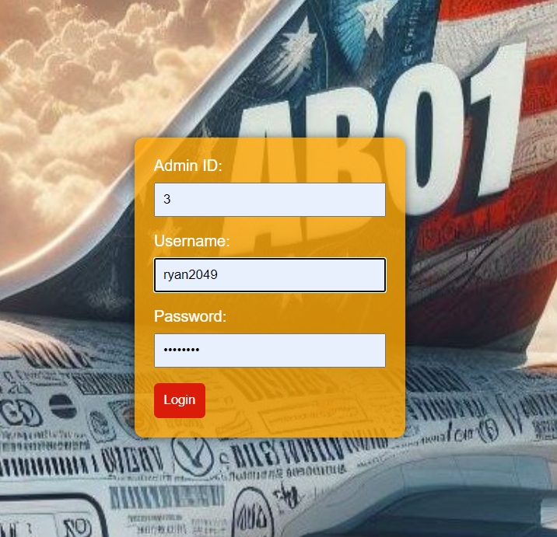

VIEW TRIPS PAGE : VIEWTRIP.PHP

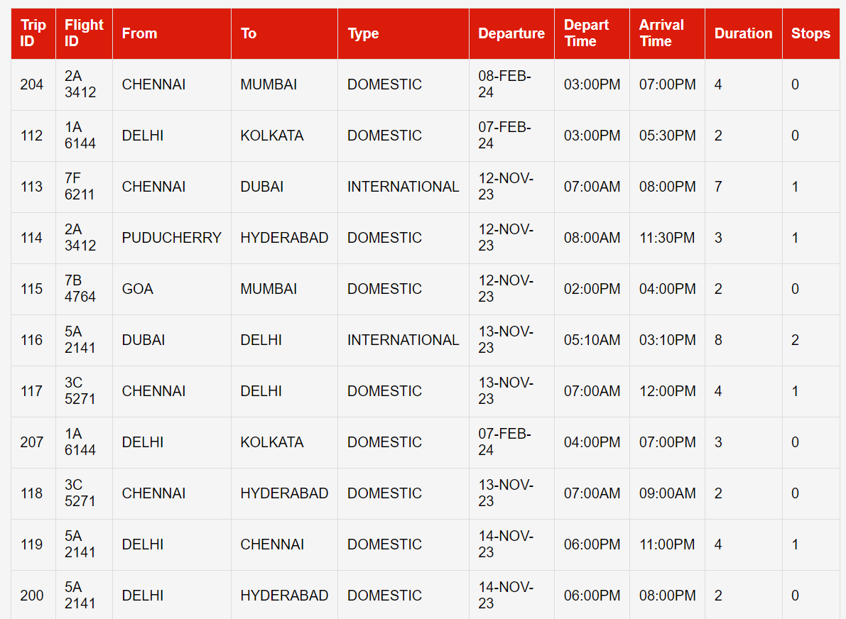

ADD TRIP PAGE : ADDTRIP.PHP

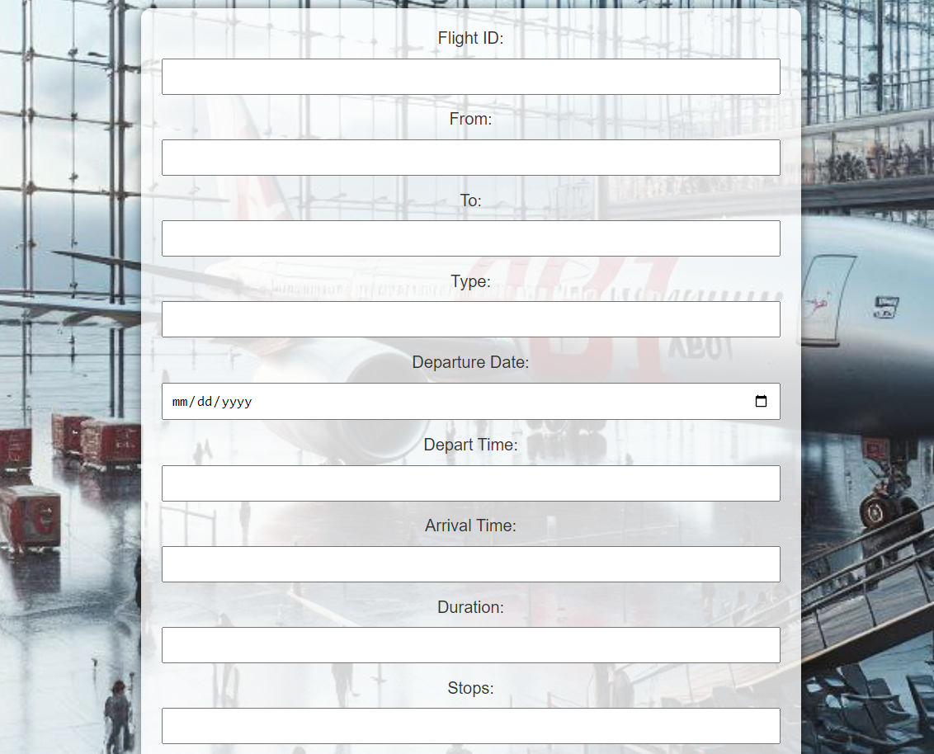

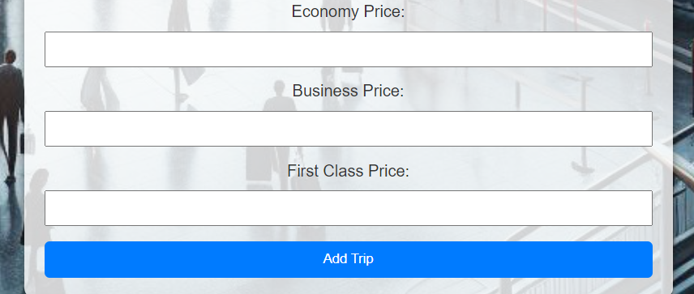

MANAGE TRIP PAGE (DELAY) :

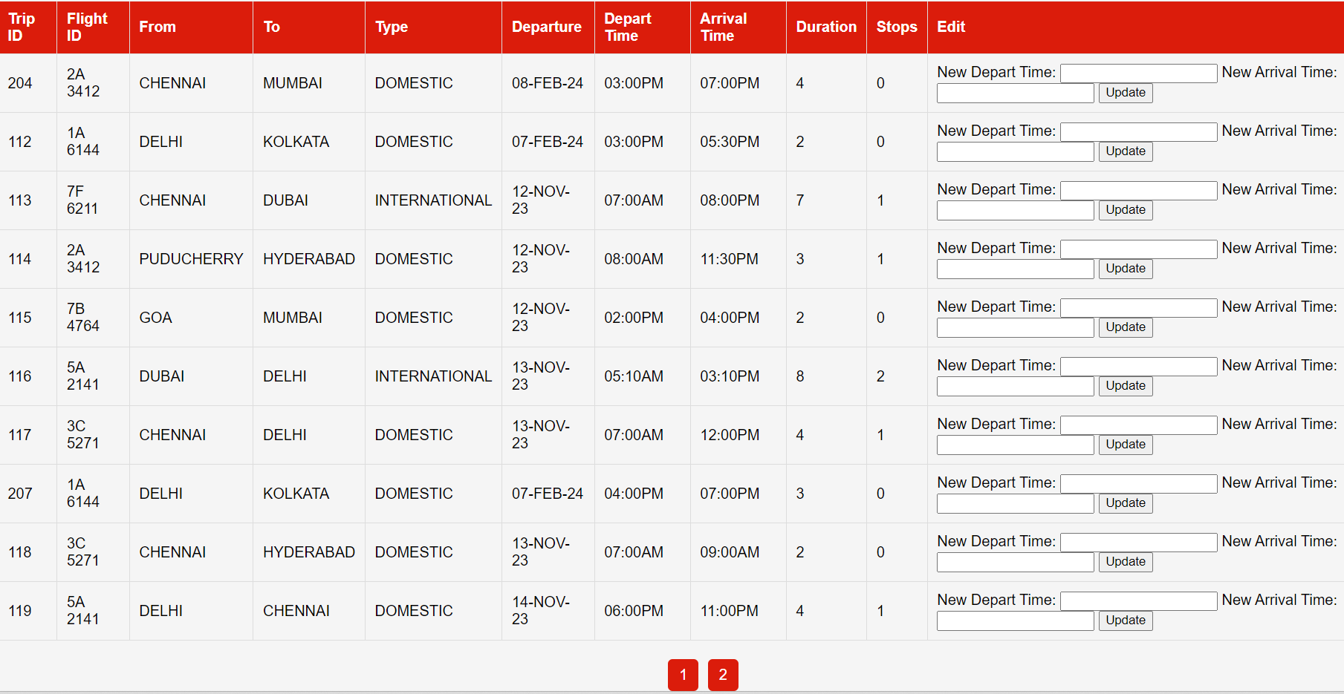

VIEW BOOKINGS PAGE :

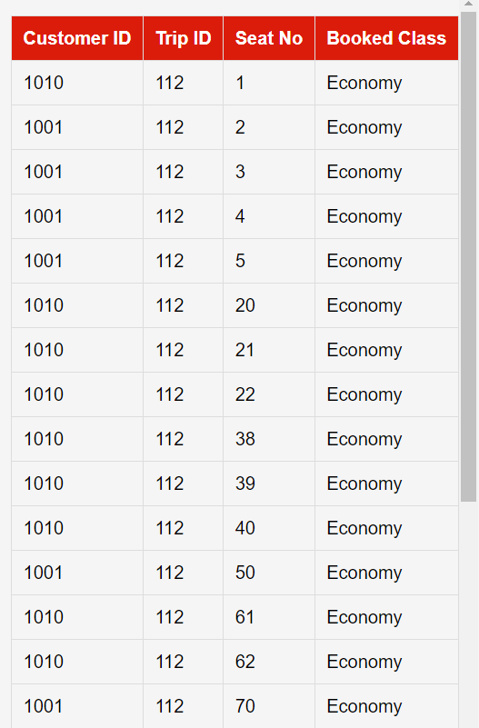

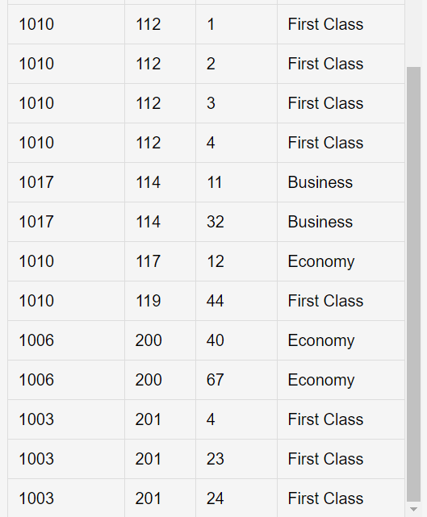

DELETE TRIP PAGE:

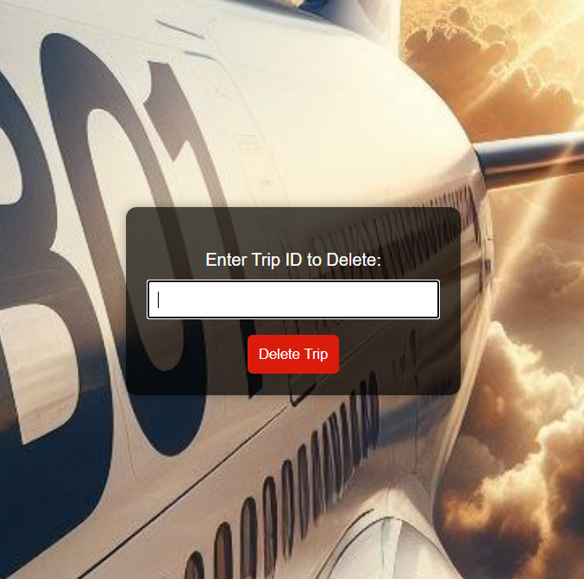

ADD ADMIN PAGE:

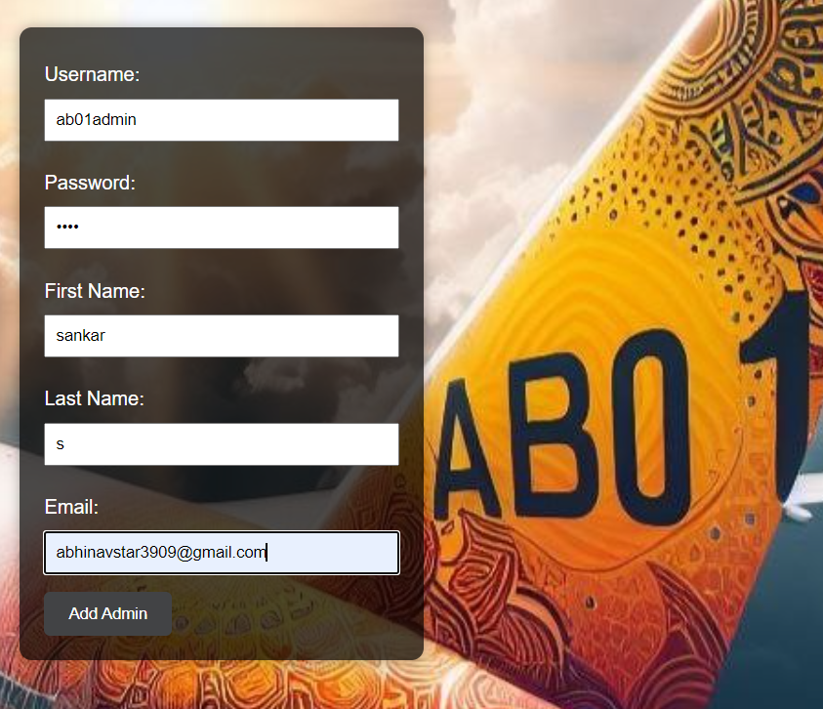

ADMIN LOGS PAGE:

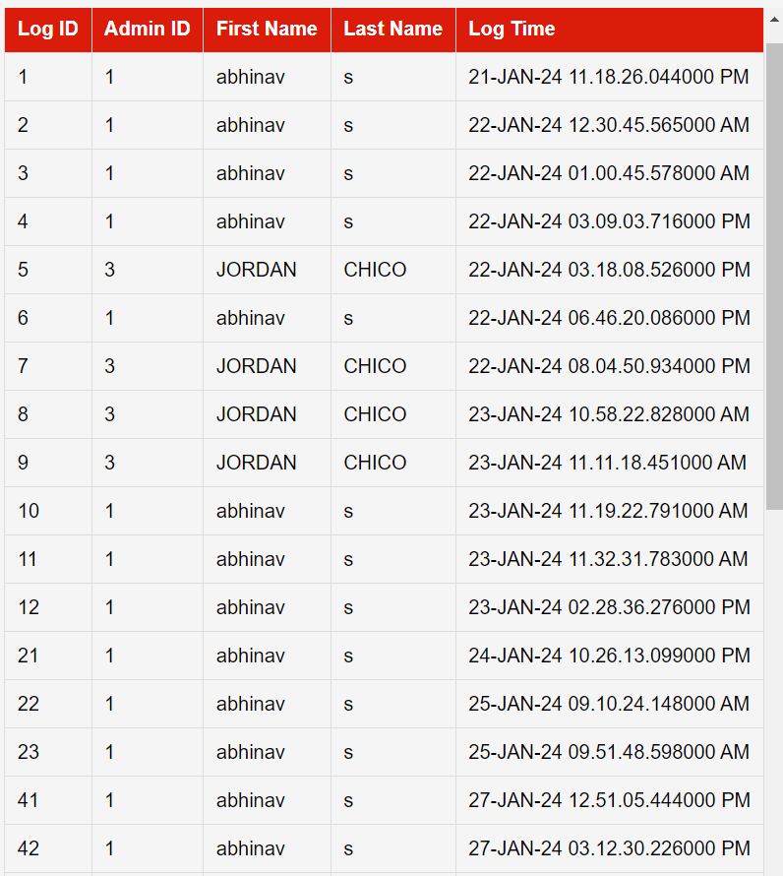

PERMIT PAGE : PERMIT.PHP

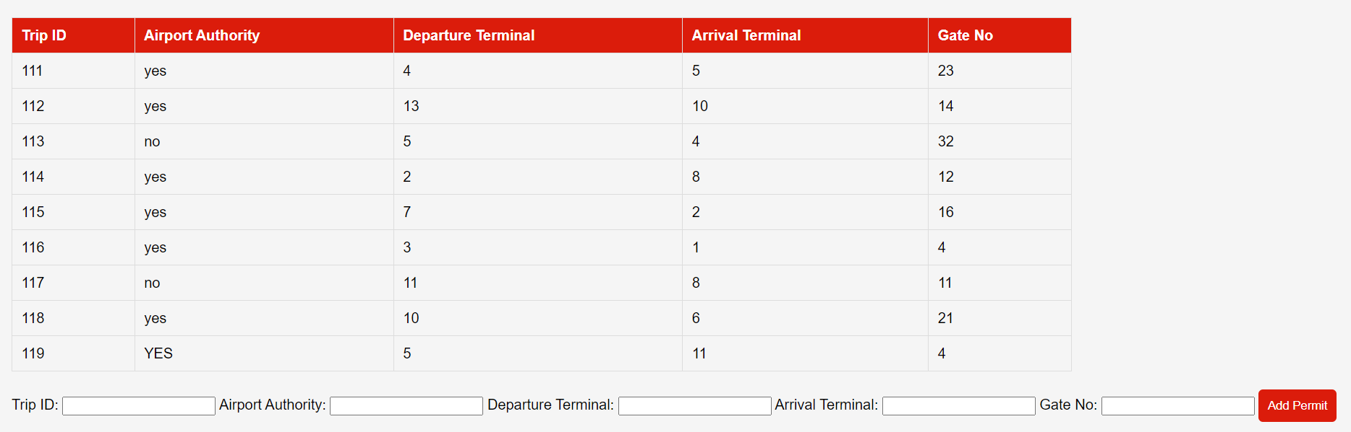

ADD FLIGHTS PAGE : ADDFLIGHT.PHP

